Conversion Pilot AI

E-commerce Customer Behavior & Conversion Analysis

Group Name: Hackaholics

Team Members Name:-
- Nur Iliya Maisarah Binti Mustafa Kamal
- Muhammad Danial bin Sa'adon
- Asyraf Azmi

Date: 11 April 2025

1.0 Problem Statement
E-commerce businesses generate vast amounts of user interaction and transaction data on a daily basis; however, many struggle to transform this data into timely and actionable insights.
As a result:
- Business issues are often identified too late for effective intervention
- High-intent customers abandon carts without any preventive action
- Opportunities for personalized engagement and targeted recovery are missed
These challenges contribute to significant revenue loss, reduced operational efficiency, and suboptimal customer experience.
2.0 Solution Overview
This project introduces Conversion Pilot AI, an AI-powered e-commerce optimization platform that integrates analytics, prediction, and recommendation into a unified intelligent system.
The platform is designed to:
- Analyze user behavior and transaction patterns
- Identify critical drop-off points within the conversion funnel
- Predict cart abandonment before purchase loss occurs
- Recommend recovery strategies and next-best products
By combining these capabilities, the platform enables businesses to make proactive, data-driven decisions that improve conversion rates and enhance customer engagement.

2.1 Objectives
This project introduces Conversion Pilot AI, an AI-powered e-commerce optimization platform that integrates analytics, prediction, and recommendation into a unified intelligent system.
The platform is designed to:
- Analyze user behavior and transaction patterns
- Identify critical drop-off points within the conversion funnel
- Predict cart abandonment before purchase loss occurs
- Recommend recovery strategies and next-best products
By combining these capabilities, the platform enables businesses to make proactive, data-driven decisions that improve conversion rates and enhance customer engagement.

2.2 Target Users
The target users of Conversion Pilot AI are stakeholders involved in managing and optimizing e-commerce performance.
- E-commerce Businesses
Organizations that aim to understand customer behavior, improve conversion rates, and increase overall revenue.
- Marketing Teams
Teams responsible for campaign planning and execution, who require insights on user engagement, traffic sources, and optimal timing for promotions.
- Business Analysts and Data Analysts
Professionals who rely on data-driven insights to monitor performance, identify trends, and support strategic decision-making.
- Product Managers
Individuals focused on enhancing user experience, particularly in optimizing the customer journey and reducing cart abandonment.

2.3 Market Relevance
The rise of digital commerce has increased competition among online retailers, making conversion optimization and customer retention critical success factors.
Businesses that fail to leverage behavioral data and predictive intelligence risk losing revenue to competitors with smarter, data-driven systems.
Conversion Pilot AI addresses this need by equipping businesses with intelligent tools to optimize the customer journey and maximize conversion opportunities.

3.0 Dataset Description
This project utilizes an e-commerce clickstream dataset obtained from Kaggle.
The dataset contains detailed user interaction data across multiple stages of the customer journey.

Key Metrics:
- Total Users: 19,945
- Total Events: 760,000
- Conversion Rate: 27.98%
- Total Revenue: $111.65M

Key Columns:
- user_id – unique user identifier
- event_type – page_view, add_to_cart, checkout, purchase
- product_id – product interaction
- event_timestamp – time of interaction
4.0 Data Preparation
Data preprocessing was conducted using Python in Google Colab:
- Removed duplicate records
- Handled missing values
- Converted timestamp into datetime format
- Merged datasets to create a unified dataset
- Selected relevant features for analysis
The cleaned dataset was then imported into Power BI for visualization.

5.0 System Overview
This project consists of three main components:

5.1 User Behavior Analysis
- Analyze user interactions across different stages
- Identify behavioral patterns and trends
- Visualize insights using Power BI dashboards

5.2 Cart Abandonment Prediction
- Machine learning model predicts the likelihood of cart abandonment

Model Performance
- Accuracy: 86%
- ROC-AUC Score: 93.45%

5.3 Product Recommendation System
- Suggests relevant products based on user behavior
Step 1 — Filter the right events
- We only look at add_to_cart events because purchase rows had no product info. We keep only the 4 columns we need and drop any rows with missing values. Think of this as building a clean shopping basket list — who put what into their cart.
Step 2 — Build the co-cart matrix
- This is the heart of the recommender. For every customer, we look at ALL the products they carted, then count every possible pair.
- We do this for all 6,106 customers. By the end, we have a giant scoreboard of "how many times were these two products carted together." The higher the score, the stronger the connection between two products.
Step 3 — The recommend function
- When you ask for recommendations for a product, the function simply looks up all pairs that involve that product, collects the scores, sorts them from highest to lowest, and returns the top 5. 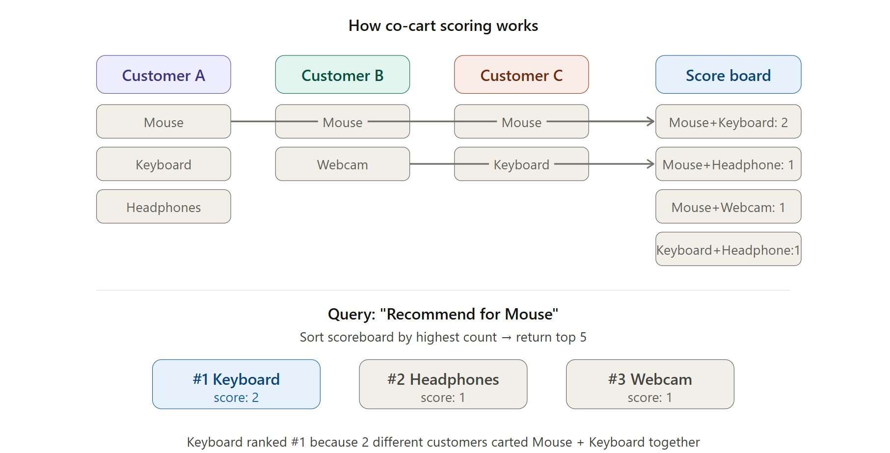
- 5.4 System Architecture Diagram
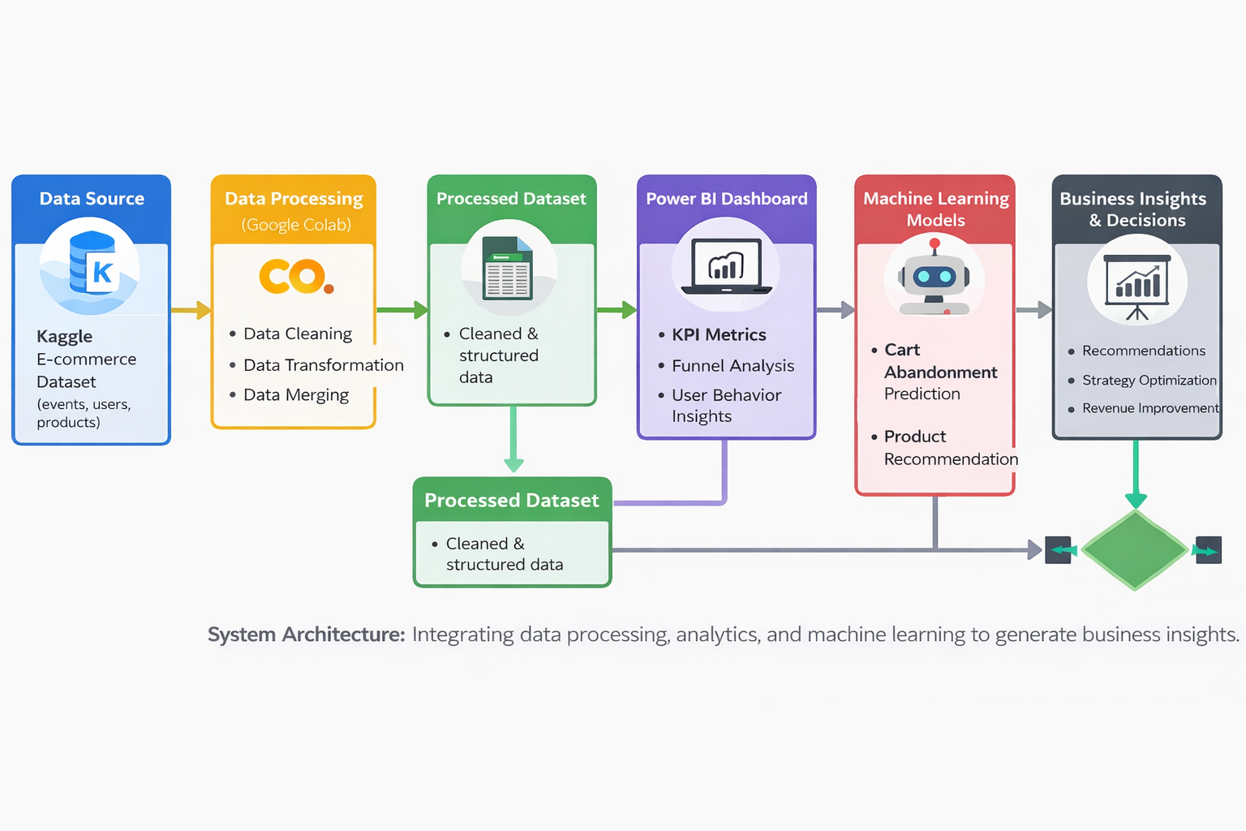
The system architecture of Conversion Pilot AI illustrates the end-to-end workflow from raw data to actionable business insights.
The process begins with the collection of raw data from the e-commerce dataset, which includes user interactions such as page views, add-to-cart actions, and purchases. This data serves as the foundation for analysis.
Next, the data is processed in Google Colab, where data cleaning and transformation are performed. This includes removing duplicates, handling missing values, and converting data into a suitable format for analysis.
The processed data is then utilized in Power BI to develop interactive dashboards. These dashboards provide insights into user behavior, sales performance, and conversion patterns, enabling better understanding of customer activity.
In parallel, the cleaned data is also used to build machine learning models. These include a cart abandonment prediction model to identify users likely to drop off, and a product recommendation system to suggest relevant items based on user behavior.
Finally, the outputs from both the dashboard and machine learning components are combined to generate actionable business insights. These insights support decision-making, improve customer experience, and help increase conversion rates and revenue.

6.0 Methodology

6.1 Behavioral Analysis
User interactions were analyzed based on event types:
- Page view
- Add to cart
- Checkout
- Purchase

6.2 Funnel Analysis
User journey tracked as:
Page View → Add to Cart → Checkout → Purchase
This helps identify drop-off points in the conversion process.

6.3 KPI Calculation
Key metrics were calculated using DAX in Power BI:
- Total Users
- Total Events
- Conversion Rate
- Purchase Count

6.4 DAX Measure

1. Customer Conversion Rate
This metric measures the percentage of users who completed a purchase.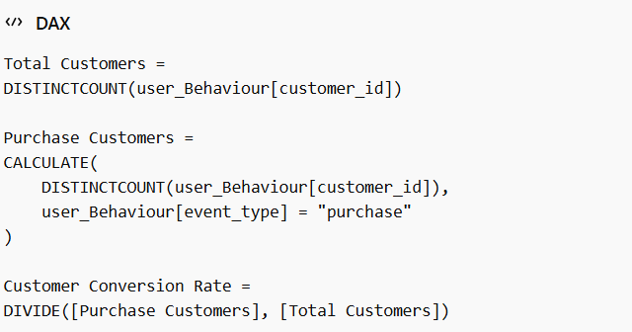

Explanation:
This metric helps identify how many users successfully convert into customers, providing insight into overall platform effectiveness.

2. Purchase Conversion Rate (Session-Based)
This metric evaluates conversion based on user sessions.
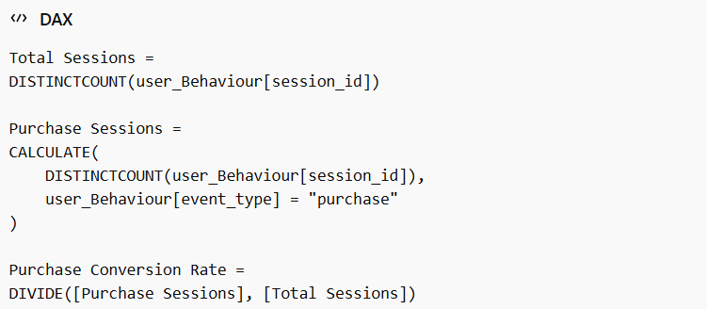
Explanation:
This measure tracks how many sessions lead to a purchase, helping to understand session-level effectiveness and user intent.
7.0 Dashboard Overview

7.1 Revenue, Sales Performance & Geographic Insights
- Total revenue reached $111.65M
- Revenue trend shows consistent activity with fluctuations over time
- Average order value is $357.61, indicating strong purchasing power
- United States contributes the highest revenue (~$21M)
- Followed by United Kingdom and India
- Indicates strong market concentration in specific regions
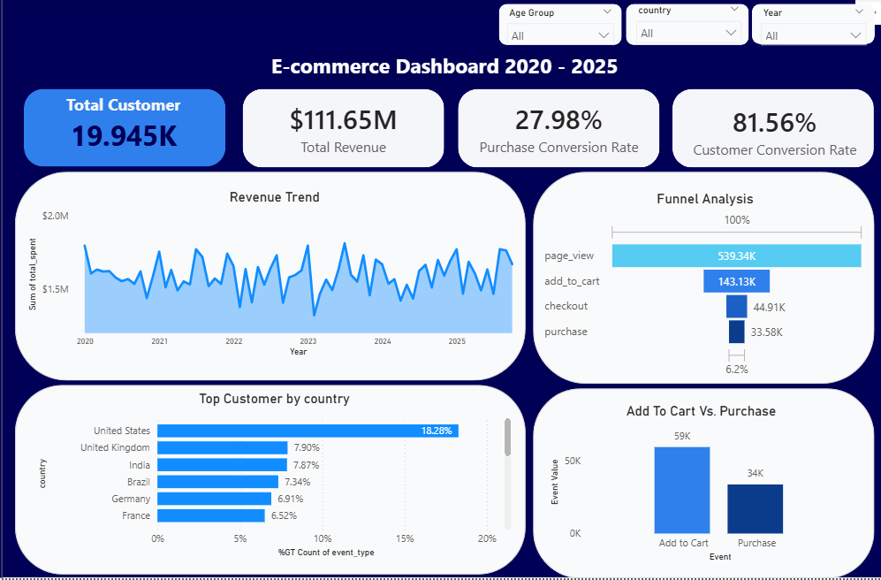

7.2 Product & Category Insights
- Top-selling products include:
  - Lipstick LightBlue 766
  - Conditioner Cornflower
- High-performing categories:
  - Beauty
  - Fashion
  - Home & Kitchen
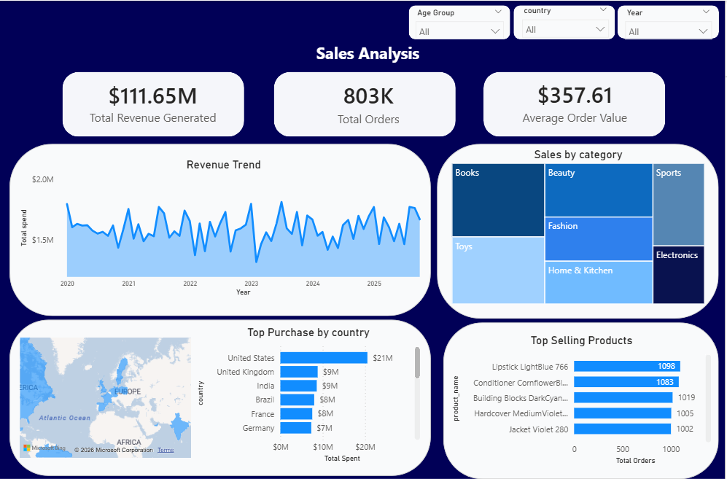

7.3 Traffic & User Behavior
- Total sessions: 120K
- Peak activity occurs around 12 AM
- Organic and direct channels are the top traffic sources
- Average interactions per user: 38.15 Click
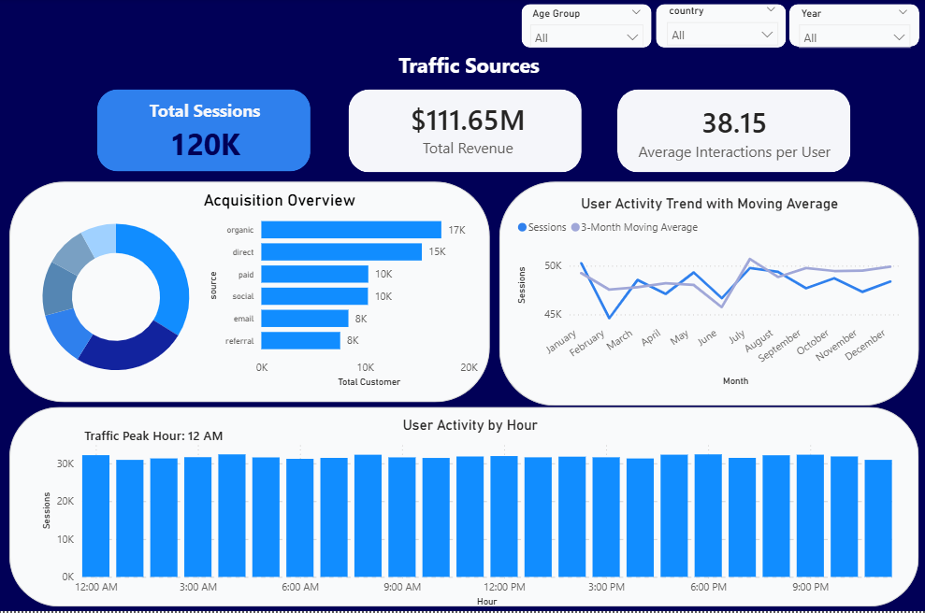

7.4 Customer Insights
- Customer conversion rate: 81.56%
- Highest spending group:
  - Senior (51–100 years old)
- Followed by middle-aged users
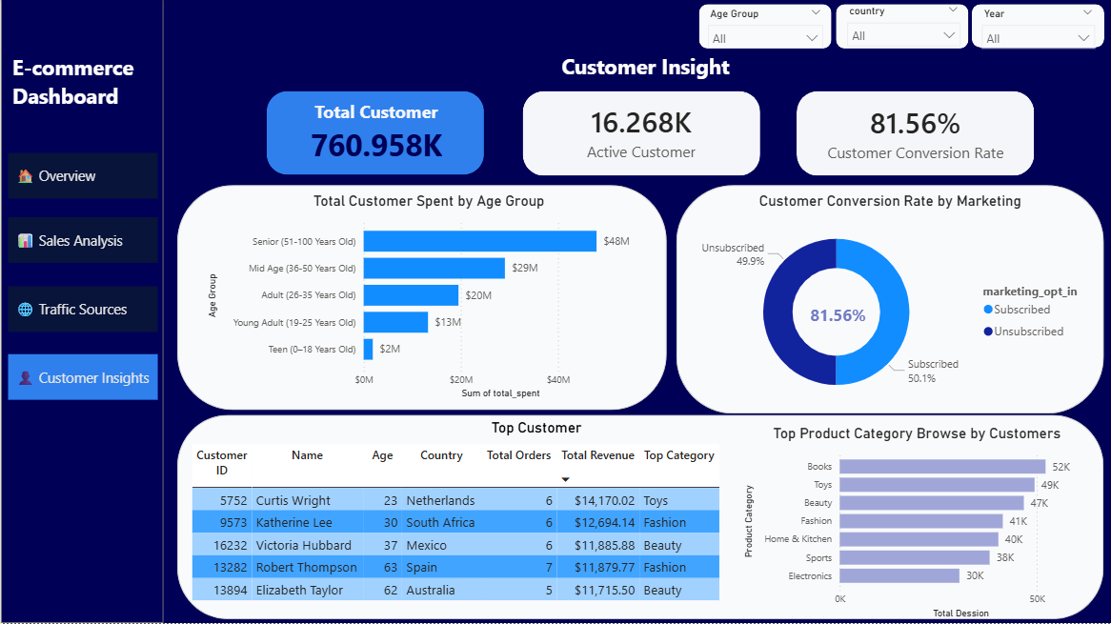

8.0 Key Insights
- The platform shows high user engagement with approximately 760,000 events, indicating strong customer interaction.
- The overall conversion rate of 27.98% suggests that while users are active, there is still significant room for improvement in converting interactions into purchases.
- A major drop-off occurs between the add-to-cart and checkout stages, highlighting a critical point of user abandonment.
- This behavior suggests potential friction in the checkout process, such as complexity, cost concerns, or user experience issues.
- Revenue is highly concentrated in specific countries, particularly the United States, indicating key markets that drive business performance.
- Product categories such as Beauty and Fashion dominate sales, showing strong customer preference for lifestyle-related products.
- User activity peaks at specific hours (around 12 AM), suggesting optimal timing for targeted promotions and marketing campaigns.

9.0 AI Implementation

9.1 Cart Abandonment Prediction
A machine learning model was developed to predict whether users are likely to abandon their cart before completing checkout.
The prediction engine is powered by a Random Forest Classification Model, trained using session-based behavioral and transactional features including browsing activity, session duration, device type, traffic source, and customer engagement metrics.

Model Performance
- Accuracy: 86%
- ROC-AUC Score: 93.45%
Impact:
- Enables targeted marketing and intervention strategies
- Reduces potential revenue loss by identifying at-risk users early
- Supports proactive decision-making for conversion optimization

9.2 Product Recommendation System
A recommendation system was implemented to suggest relevant products based on user purchase and cart behavior.
The engine uses an Item-Based Collaborative Filtering Method, which identifies products frequently added to cart together and recommends complementary items accordingly.
Impact:
- Improves personalization of shopping experience
- Increases user engagement and conversion opportunities
- Supports upselling and cross-selling strategies

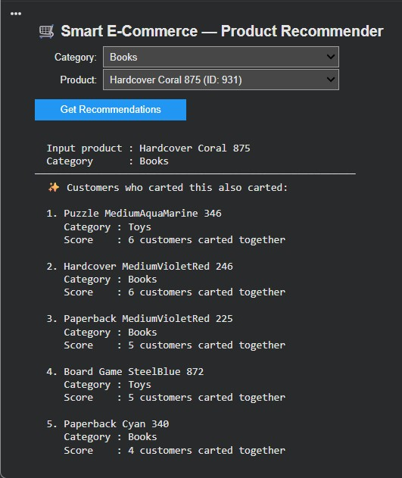

10.0 Recommendations
- Optimize the checkout process to reduce friction and minimize drop-off between the add-to-cart and purchase stages.
- Implement targeted campaigns for cart abandonment, such as reminders, discounts, or personalized offers to recover potential lost sales.
- Leverage personalized product recommendations to enhance user experience and increase the likelihood of conversion.
- Focus marketing efforts on high-performing countries, such as the United States, to maximize revenue impact.
- Promote top-performing product categories, particularly Beauty and Fashion, to capitalize on existing customer demand.
- Schedule marketing campaigns during peak user activity periods (e.g., around 12 AM) to improve engagement and conversion rates.

11.0 Business Impact
- Increased conversion rates and revenue potential by identifying and addressing key drop-off points in the customer journey.
- Enhanced customer experience through a smoother checkout process and personalized product recommendations.
- Improved targeting and personalization, enabling businesses to engage the right customers with relevant offers and content.
- More effective marketing strategies by focusing on high-performing regions, categories, and peak activity periods.
- Stronger data-driven decision-making, allowing businesses to leverage insights from dashboards and machine learning models for continuous improvement.

12.0 Tools and Technologies
The following tools and technologies were utilized in the development of this project:
- Python (Google Colab) – Data preprocessing, machine learning model development, and recommendation logic implementation
- Power BI – Dashboard visualization and business intelligence reporting
- DAX – Advanced data calculations and performance metric analysis in Power BI
- Machine Learning Libraries – Predictive analytics and classification modeling
- FastAPI – Backend API deployment for cart abandonment prediction
- Next.js – Frontend web application and prototype interface development

13.0 Challenges and Limitations
- Use of synthetic dataset
- Limited real-world behavioral complexity
- Time constraints

14.0 Future Improvements
- Integration of real-time analytics and prediction pipelines for live production environments
- Development of more advanced recommendation algorithms, including hybrid and deep learning-based recommenders
- Integration with live e-commerce platforms and APIs for real-world deployment
- Expansion of predictive capabilities into churn prediction and customer lifetime value analysis
- Enhanced personalization through user-level recommendation and behavioral segmentation

